**Setting up DCT Tool Kit**

1. **Click Windows Search in bottom left corner.**

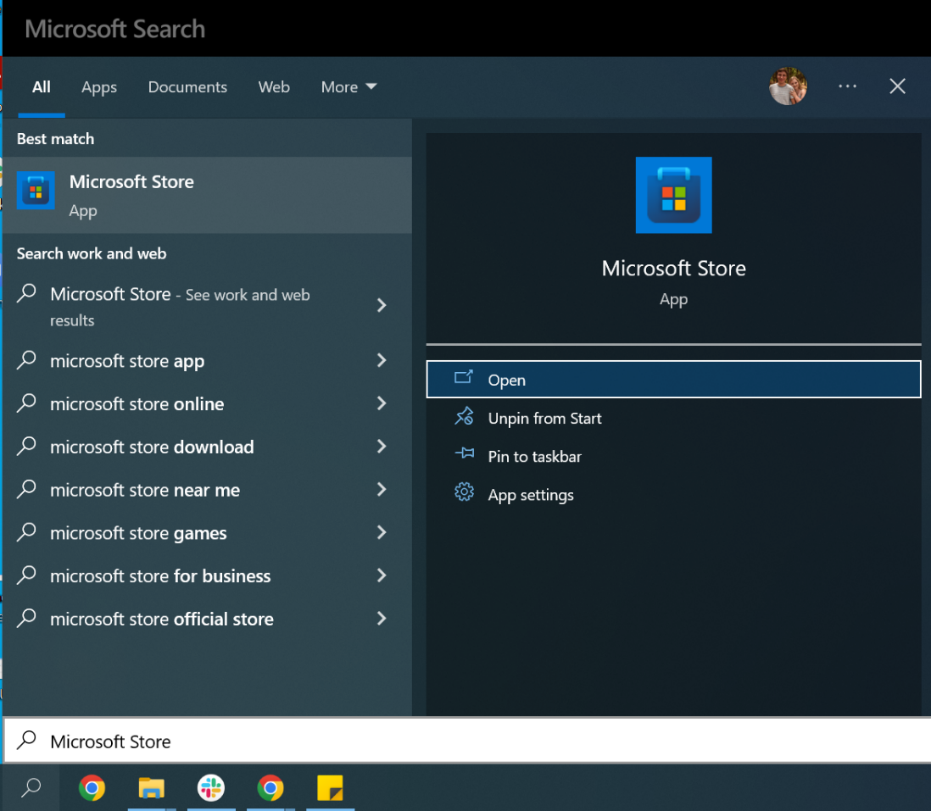

1. **Search “Python 3.9”**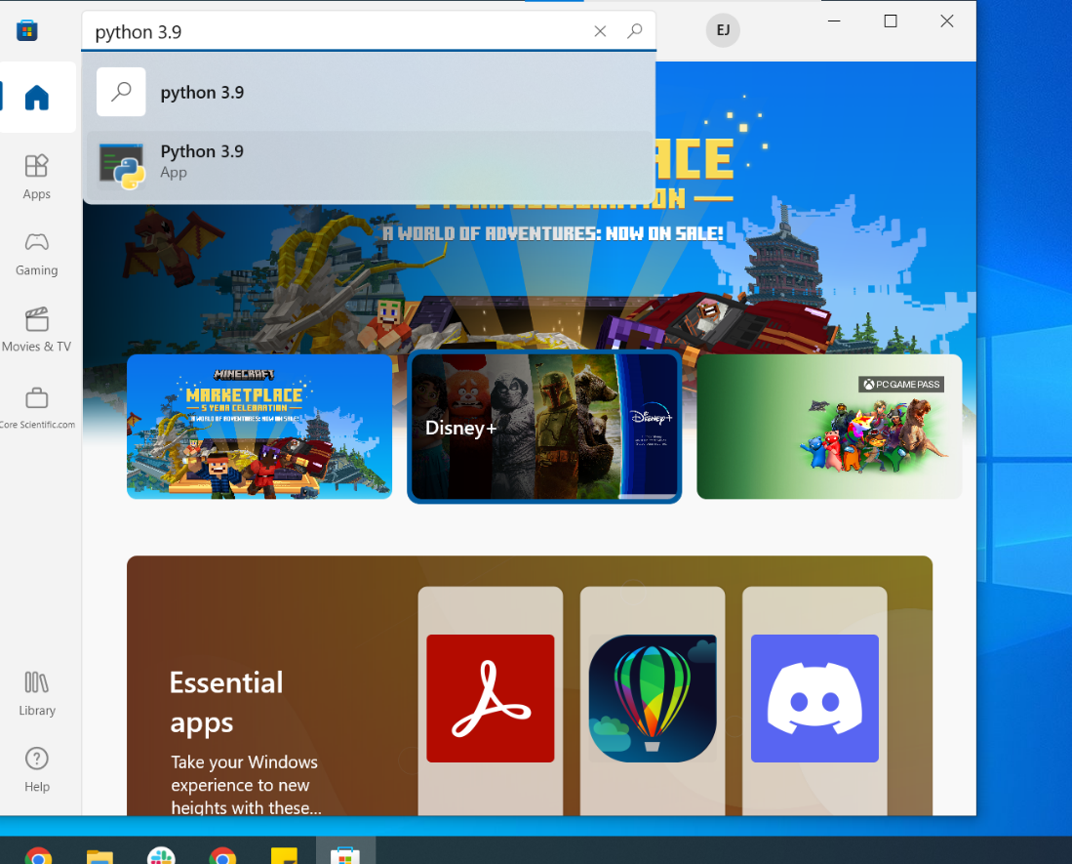
2. **Click “Get” and wait for download.**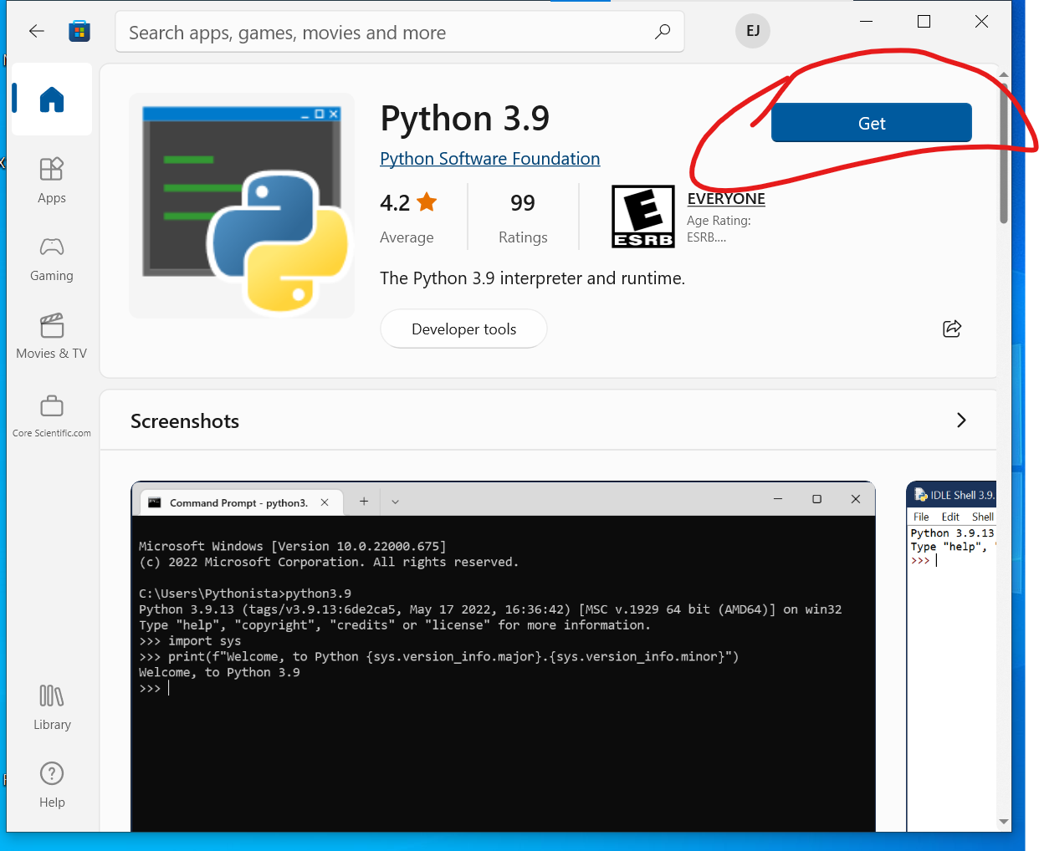
3. **In DCT Tool Kit folder, double click the RunMeFirst file**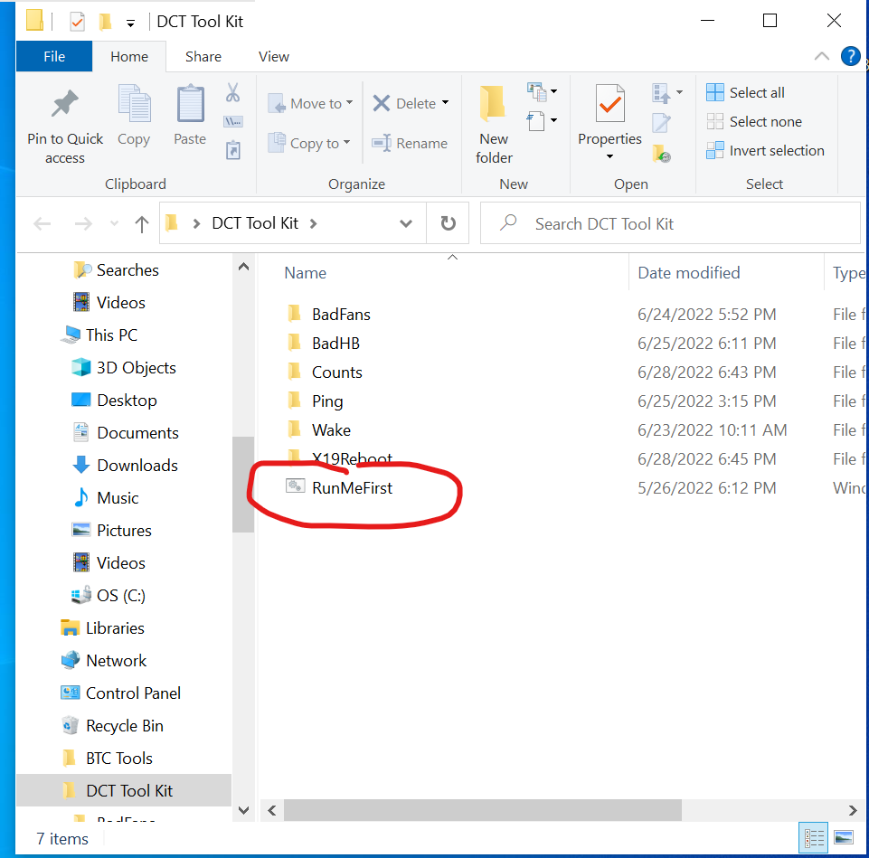
4. **Left-Click then right-click on the Run file and select “Edit”**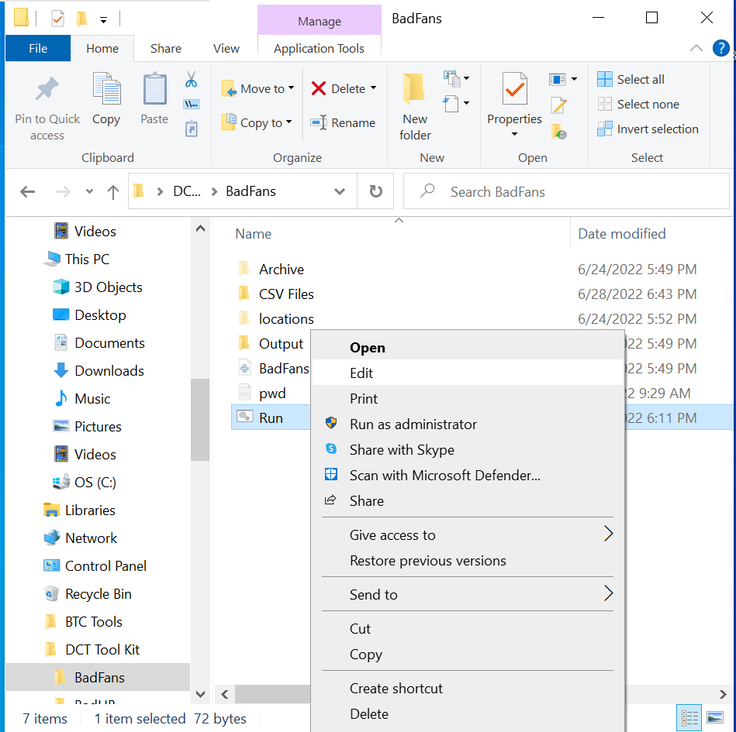
5. **Click the address bar in File Explorer and copy the highlighted directory.**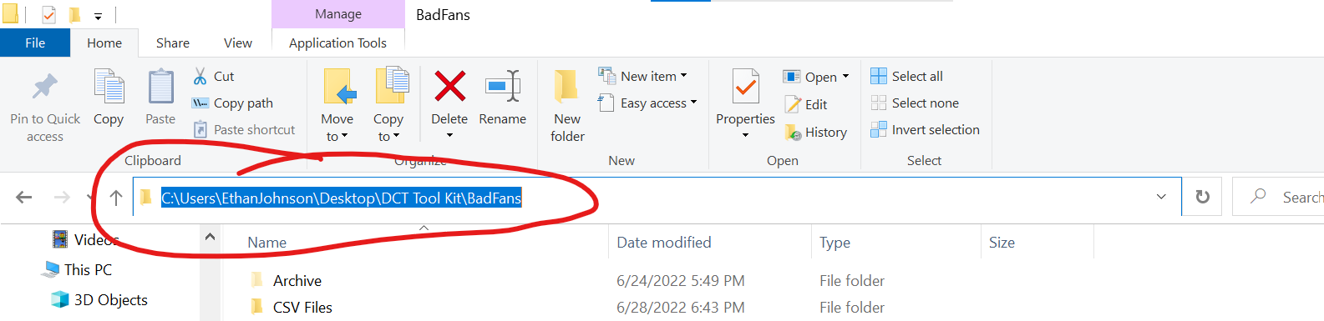
6. **In Run file notepad, paste over the 2nd line, leaving “cd “ before your directory, Save file**

